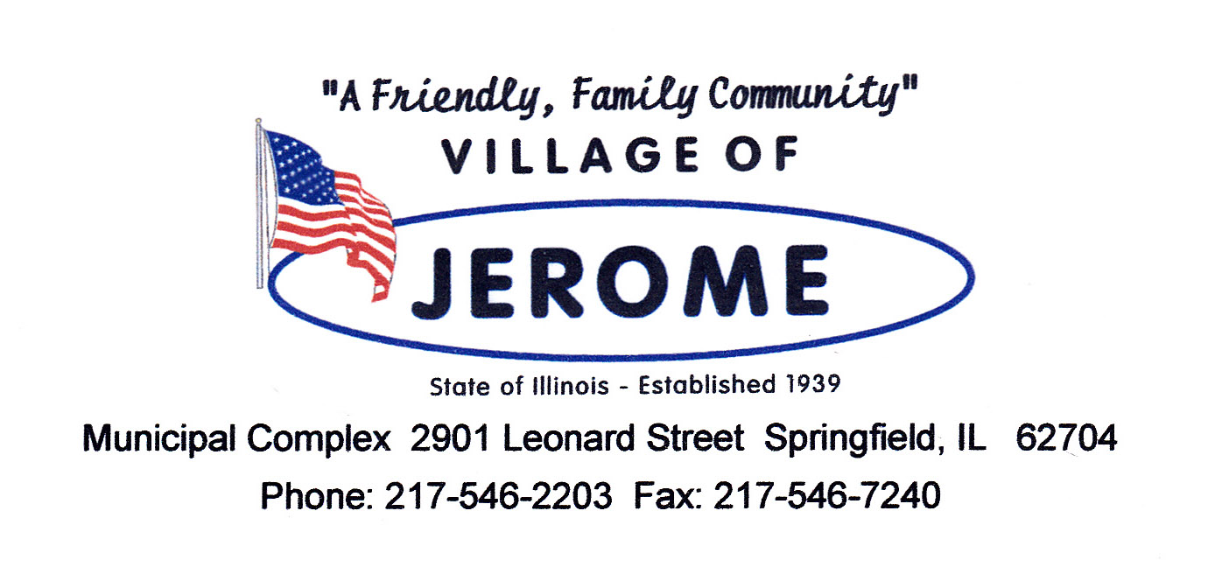
Kathy DeHart Trustee
Leigh Irons Trustee
Ralph Irons Trustee
Dale Lael Trustee
Courtney Wick Trustee
Katrina Christofilakos Trustee
Emily Snow Treasurer
Michael P. Lopez
Village President

Lisa Cave
Village Clerk

Steve Roth
www.villageofjerome.com
Executive Assistant

To: Jerome Residents

On the week of July 21st ,2025 and the week of June 28th, 2025, the Jerome Public Works department will be flushing fire hydrants and exercising water main valves near your home or business. The Illinois Environmental Protection Agency requires that all fire hydrants be tested and flushed on an annual basis.

This allows us to flush any sediment from valves, hydrants and water mains, allowing for clean healthy water.

You may notice a discoloration and possibly some sediment in your water. There is no need to boil water or take any other measures. It is recommended to run water from an outdoor spigot or a bathtub faucet to clear your system of any discoloration or sediment. Please see the Village of Jerome website for more information.

Hydrants and Valves will be exercised and flushed in zones in relation to the loop of Jerome’s water system. Zones are as follows:
Week 1 includes Zones 1 through 5. Week 2 is Zones 6 through 8
Zone 1: north side of Wabash Ave. Zone 2: south side of Wabash Ave.
Zone 3: Calland Dr., Jerome Ave., and intersections of Jerome Ave.
Zone 4 : W. Grand Ct., Vernon Ave., and all intersections of Vernon Ave.
Zone 5: Alberta Ln., Reed Ave., and all intersections of Reed Ave.
Zone 6 : Barbara Ct., Homewood Ave., and all intersections of Homewood Ave.
Zone 7 : Glenn Ave., and all intersections of Glenn Ave.
Zone 8: Iles Ave. from Owens Ln. to Welch

Thank you for your patience and understanding while we do our flushing and maintenance.

Any questions you may call Public Works directly.

David Wilken Public Works Director
Village of Jerome
217-546-9647
Email: publicworks@villageofjerome.com

